Electronic Signature
Existing system :
In the current system we have signature control only on I-9 Verification form Section-III.

Proposed System :
When an employee has completed a document that requires electronic signature. Show pop up when the employee is ready to sign the I-9. It confirms the identity of the employee because the employee is logged in with a unique login/password and has to input his name and date of birth.
Required changes :
- Database changes :
  - Create new table for storing electronic signature (if required).
  - Create a new procedure for Insert/Update data in that table.
  - Create a new procedure to validate the data submitted by employee to Identify
(First Name, Last Name and Date of birth).

- Design changes :
  - Design new partial view for the popup (will load after each section).
  - Remove existing signature controls from the existing I-9 form.

- Coding changes :
  - Coding changes in appropriate Model and Controller.
  - Coding changes in Business Logic (if required).
Sample design :
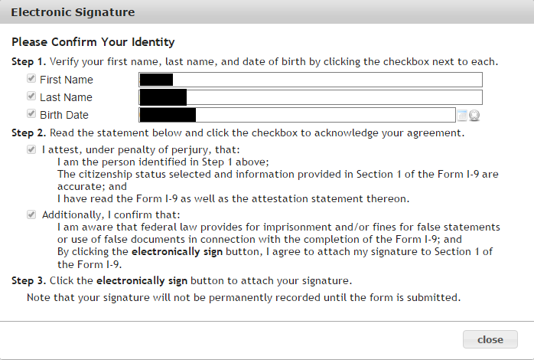
Note :
- First Name, Last Name and Date of birth checkboxes will appear on Section-I but not on Section-II.
- The signature will not be permanently recorded until the form is submitted.

Questions :
- Can you describe “Click the electronically sign button to attach your signature” In details?
- We have to show this popup after completed each section or on particular section only?
- Once an employee / employer submitted the electronic signature can he/she update it again whenever required?
- Do we need to display electronic Signature screen on Manage I-9 form?

